Date: 18/04/2024 Task:

1. Write an HTML code to display images as in the following given output by using table and image tags.
2. <!DOCTYPE html>
3. <html lang="en">
4. <body>
5. <table border="5">
6. <caption>BIKES</caption>
7. <tr>
8. <td><img src="1.png.jpg" alt="Image 1" height="220" width="220"></td>
9. <td rowspan="2"><img src="2.png.jpg" alt="Image 2"></td>
10. <td><img src="3.png.jpg" alt="Image 3" height="220" width="220"></td>
11. </tr>
12. <tr>
13. <td><img src="4.png.jpg" alt="Image 4" height="220" width="220"></td>
14. <td><img src="5.png.jpg" alt="Image 5" height="220" width="220"></td>
15. </tr>
16. </table>
17. </body>
18. </html>

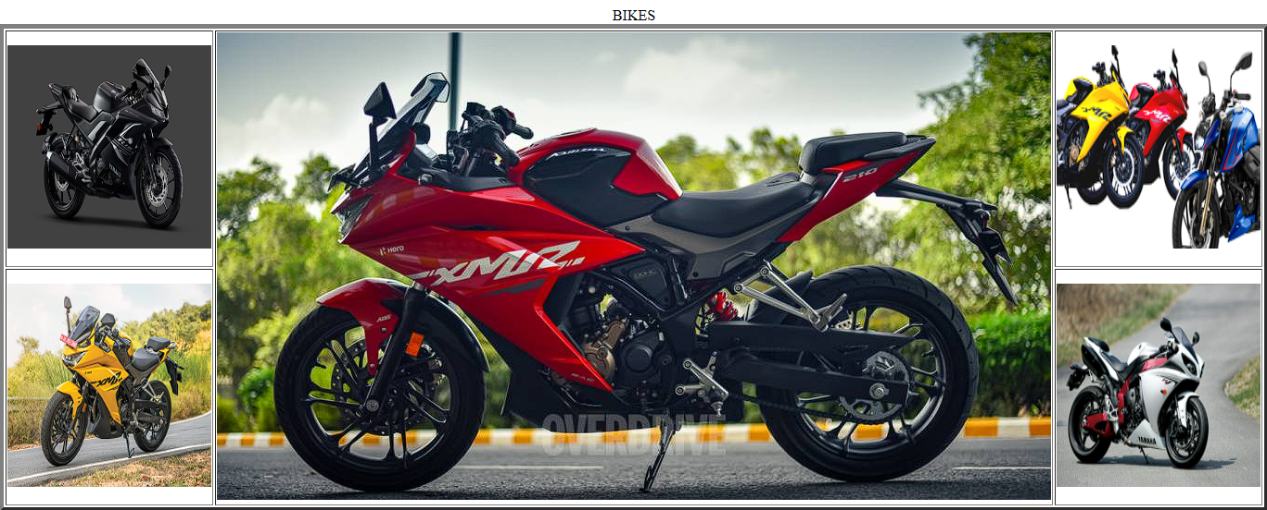

1. Write an HTML document table with lists of veg food and Non-veg with unordered lists.

<!DOCTYPE html>

<html lang="en">

<head>

    <meta charset="UTF-8">

    <meta name="viewport" content="width=device-width, initial-scale=1.0">

    <title>Document</title>

</head>

<body>

    <table border="2">

        <caption>TYPES OF FOOD</caption>

        <tr><th>SL NO</th><th>VEG FOOG</th><th>NON-VEG FOOD</th></tr>

        <tr>

            <td>1</td><td>

            <ul type="square">

                <li>Rice</li>

                <li>Sezwaan Noodles</li>

                <li>Veg Biriyani</li>

                <li>Pav Bhaji</li>

                <li>Dose</li>

                <li>Rice Sambar</li>

            </td>

            </ul>

            <td><ul type="square"  >

                <li>EGG Biriyani</li>

                <li>Chicken Biriyani</li>

                <li>Chiken Lolipop</li>

                <li>Chicken Fry</li>

                <li>Chicken Chilly</li>

            </ul></td>

        </tr> </table></body></html>

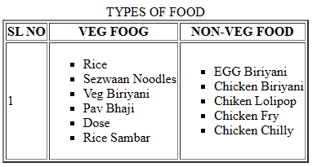

1. Write an HTML document to play audio and video files.

<!DOCTYPE html>

<html lang="en">

<head>

    <meta charset="UTF-8">

    <meta name="viewport" content="width=device-width, initial-scale=1.0">

    <title>Document</title>

</head>

<body>

<audio src =" " controls type="audio " autoplay>Song</audio>

<br>

<video src="" controls type="video " autoplay>Vedio</video>

</body>

</html>

